N+1 Problem in Hibernate / Spring Boot

1. What is N+1 Problem?
The N+1 problem is a performance issue in ORM frameworks like Hibernate where:
- 1 query is executed to fetch parent records
- N additional queries are executed to fetch child records (one per parent)
So total queries = N + 1
This leads to unnecessary database roundtrips and degraded performance.
Simple Example
- 3 Customers
- Each has Addresses
- One customer mapped to Many Customers.
Let’s say we need to get all customers with its addresses.
Instead of:
- 1 query → fetch customers
- 3 queries → fetch addresses
Total = 4 queries (N+1) → Performance issue
Visual Understanding
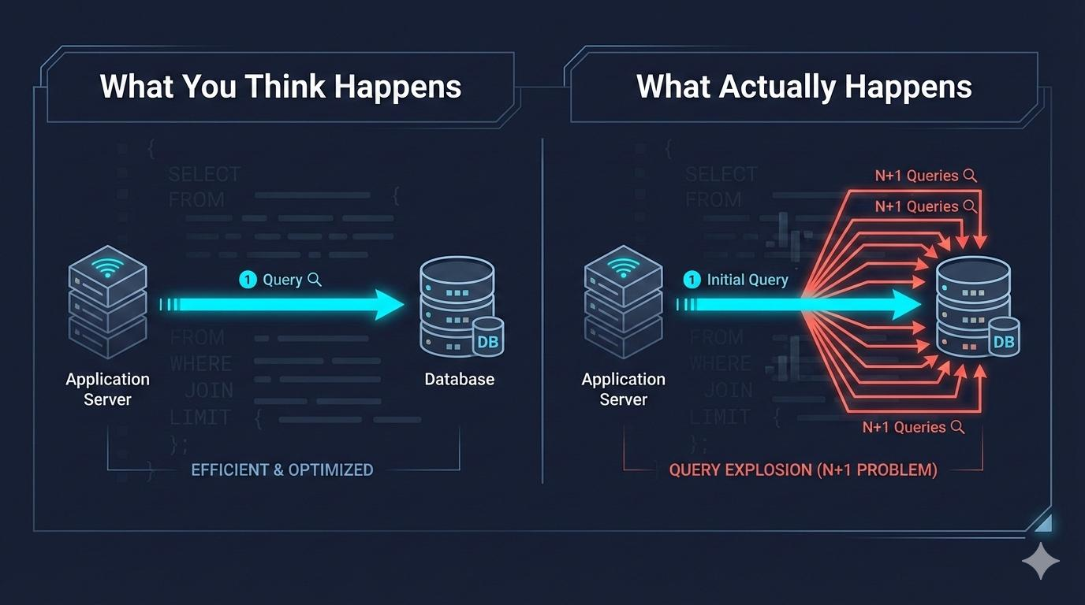

2. Why is it called N+1?
- 1 query → Fetch parent (Department)
- N queries → Fetch child (Employees per department)
Hence: N (children queries) + 1 (parent query)
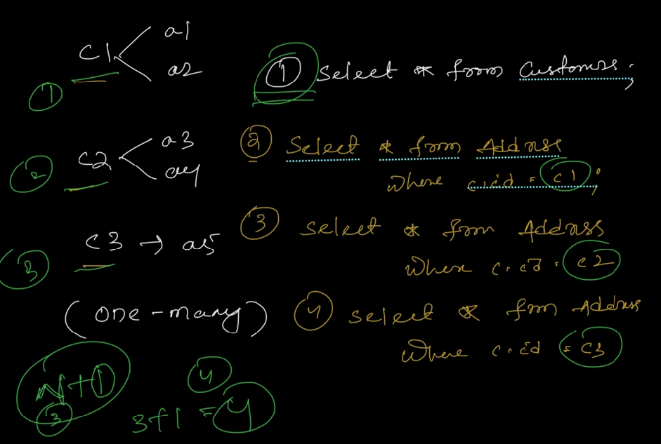
In real time, hitting DB multiple times, will downgrade the application performance.
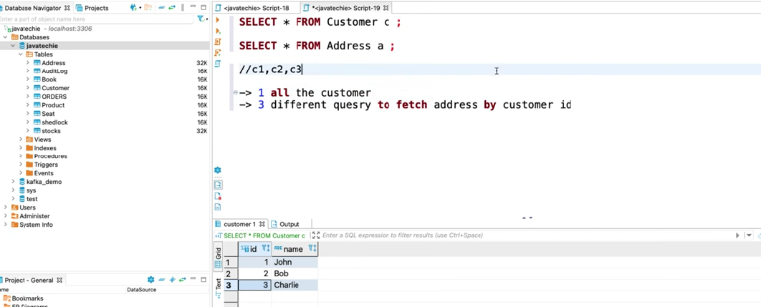
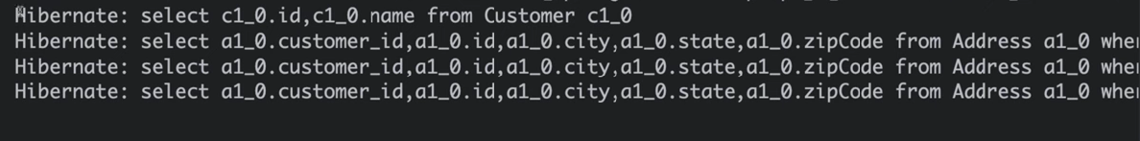
3. Root Cause
The main reason is:
Lazy Loading (Default in JPA)
- Employees are NOT loaded initially
- When accessed → Hibernate fires separate queries per department
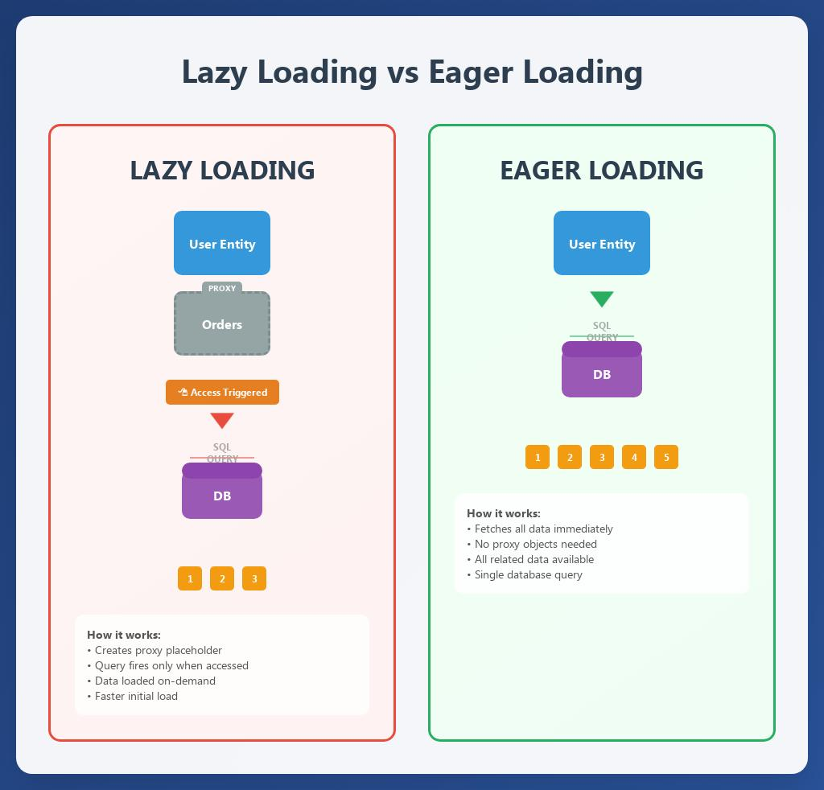

4. Example Domain
We’ll use:
- Department (Parent)
- Employee (Child)

5. WITHOUT Fix (N+1 Problem)
Entity Classes
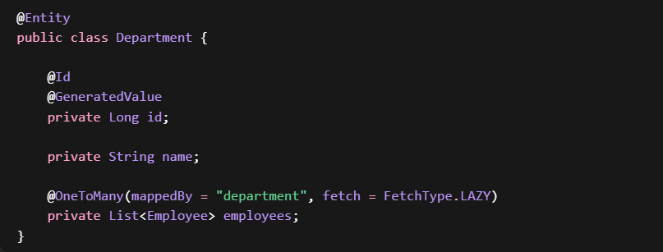
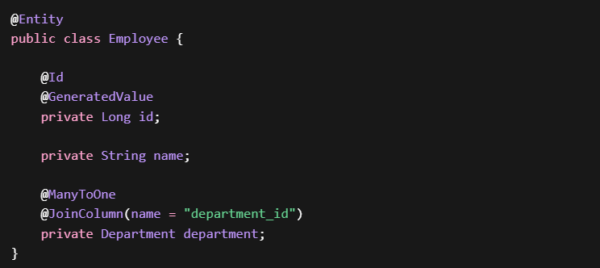

Repository

Service
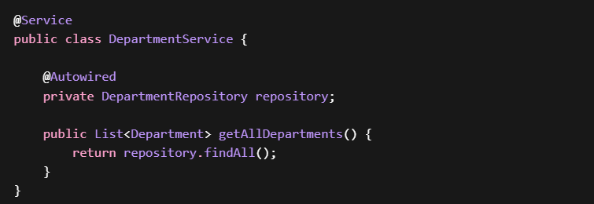
Controller
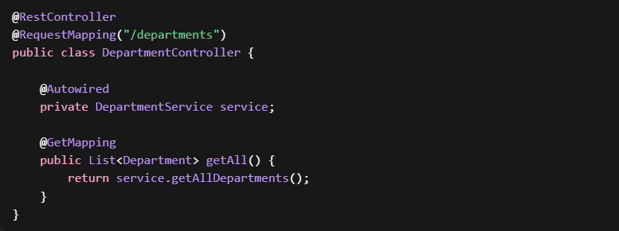

What Happens Internally?
- Query 1:
SELECT * FROM department;
- For each department:
SELECT * FROM employee WHERE department_id = ?;
If 5 departments → 6 queries total

6. WITH Fix (Optimized Solution)
Approach 1: EntityGraph (Recommended in Spring Boot)
Repository
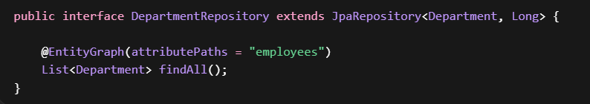
What does @EntityGraph do?
- Overrides default lazy loading
- Forces Hibernate to fetch related entities in single query
- Internally converts to:
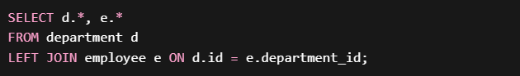
attributePaths
- Tells JPA: "While fetching Department, also fetch employees"
Result
Only ONE query executed
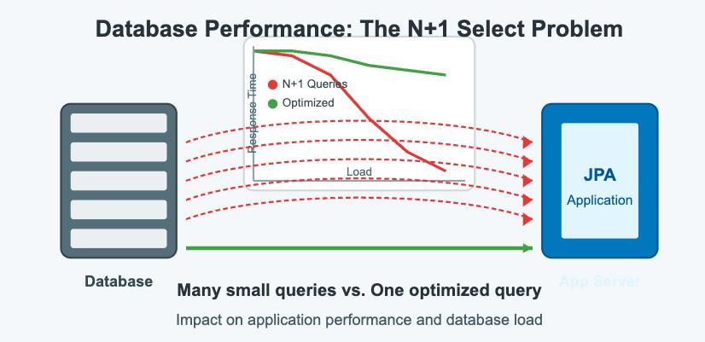
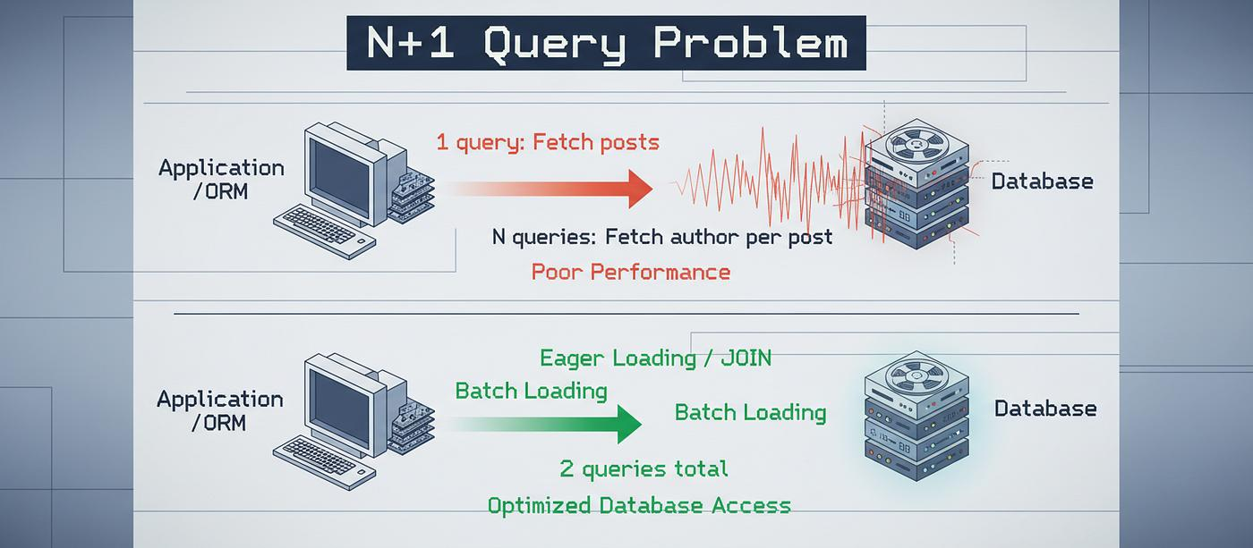

Approach 2: JPQL Fetch Join
Repository
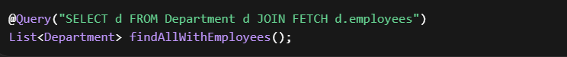
- Explicitly tells Hibernate:
"Fetch both in one query"
Result SQL
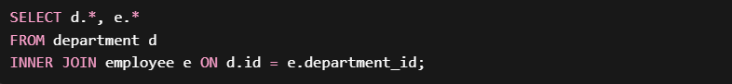
Approach 3: Set FetchType.EAGER
Why NOT recommended?
- Always loads data (even if not needed)
- Can cause:
  - Memory overhead
  - Cartesian product issues
  - Performance degradation in large systems
Approach 4: Batch Fetching
spring.jpa.properties.hibernate.default_batch_fetch_size=10
How it works
- Groups multiple lazy loads into batches
- Reduces number of queries (not fully 1 query)

Approach 5: DTO Projection
Benefit
- Fetch only required fields
- Avoids entity graph overhead
Approach | Queries | Control | Recommended
Default (Lazy) | N+1 | Low | No
EntityGraph | 1 | High | Yes
Fetch Join (JPQL) | 1 | High | Yes
EAGER Fetch | 1 | Low | No
Batch Fetch | Reduced | Medium | Sometimes
DTO Projection | 1 | High | Advanced

8. When Does N+1 Usually Occur?
- OneToMany relationships
- ManyToOne in loops
- Nested entity access inside services/controllers
- REST APIs returning full entity graphs

9. Key Takeaways
- N+1 is a query explosion problem
- Root cause = Lazy loading
- Best solutions:
  - EntityGraph (Spring Boot way)
  - Fetch Join (JPQL way)
- Avoid:
  - Blind EAGER loading

10. Summary
- N+1 Problem = 1 parent query + N child queries
- Caused by Lazy loading
- Leads to performance degradation
- Solved using:
  - EntityGraph
  - Fetch Join
  - DTO projection
- Always monitor SQL logs to detect it

Lazy Loading is causing N+1 Problem

1. What Lazy Loading Actually Means
When you define:
It means:
“Do NOT load employees when loading Department.
Load them ONLY when they are accessed.”

2. What Hibernate Really Does Internally
Hibernate does NOT put actual data in employees initially.
Instead, it puts a proxy (placeholder object).
Think of it like:
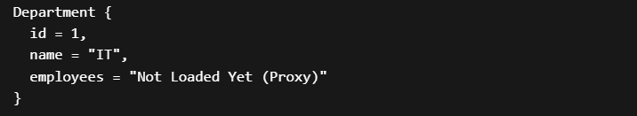
3. Step-by-Step Execution (Where Problem Starts)
Step 1: Fetch Departments
SQL:
At this point:
- Departments are loaded
- Employees are NOT loaded

Step 2: Access Employees (Trigger Point)
Now somewhere:
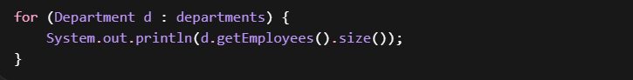THIS is the key moment.

4. What Happens Now
For each department:
Hibernate sees:
“Employees are not loaded yet → I must fetch them”
So it fires:


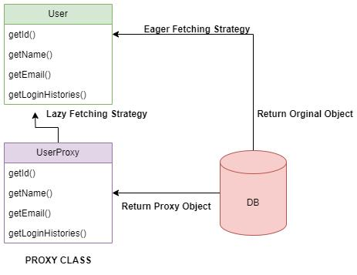

6. Why Lazy Loading Causes N+1
Lazy loading itself is NOT bad.
The problem is:
Lazy loading + Iteration = N queries
Because:
- Each access to getEmployees() triggers a query
- And you do it inside a loop
Formula
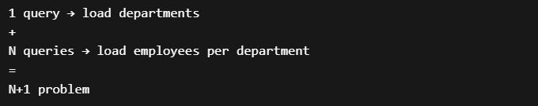
7. Important Clarification
Lazy loading is NOT always the problem.
It becomes a problem ONLY when:
- You access child data inside a loop
- OR you return entities directly in APIs
- OR you don’t control fetching strategy
8. Real-Life Analogy
Imagine:
- You go to a library and ask for list of books (Departments)
- Librarian gives you only book titles (no content)
Now for each book you say:
- “Give me pages of this book”
- “Now next book…”
- “Now next book…”
You keep going back again and again.
That’s N+1.
9. Why EntityGraph / Fetch Join Fix This
Instead of:
“Fetch later when needed”
We say:
“Fetch everything in ONE GO”
So Hibernate does:
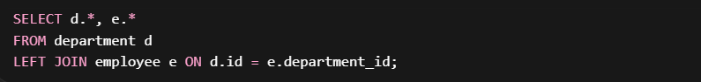Now:
- No proxy
- No repeated queries
- No N+1

10. Final Summary
- Lazy = “Load later when accessed”
- Access inside loop = “Trigger query every time”
- That repeated triggering = N+1 problem

Lazy loading causes N+1 because related entities are fetched only when accessed, and when accessed inside a loop, Hibernate executes one query per parent entity, leading to N additional queries.

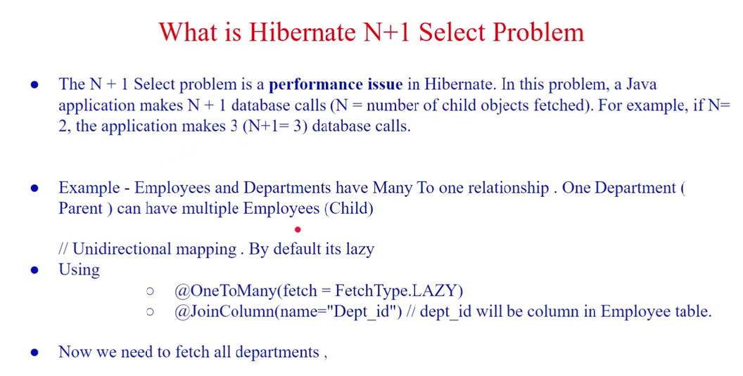
Ex: One Department can have multiple Employees
Department Entity Has OneToMany relationship with Employee.
And it is LazyLoaded, until it is not used ListOf Employees in Department entity is not fetched
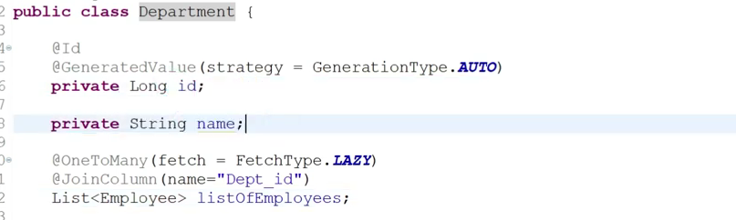

Controller calling all Departments
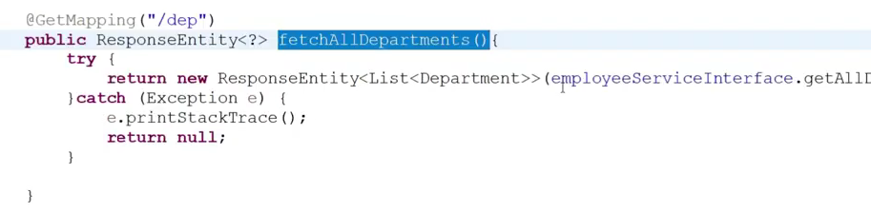

Service
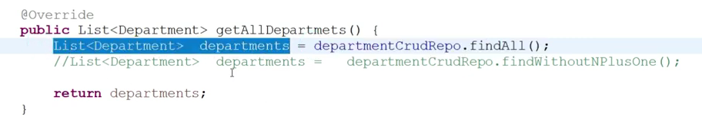
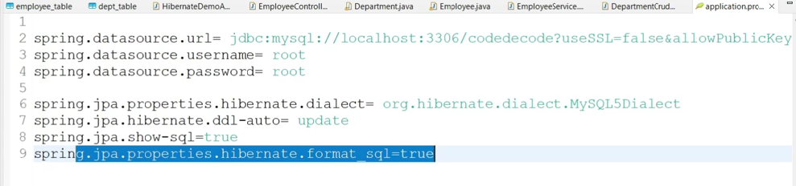
When we hit this controller, then this will call service and it fetches all the departments, and for all departments it fetches all employees N+1 Queries hit ( N+1 Problem)
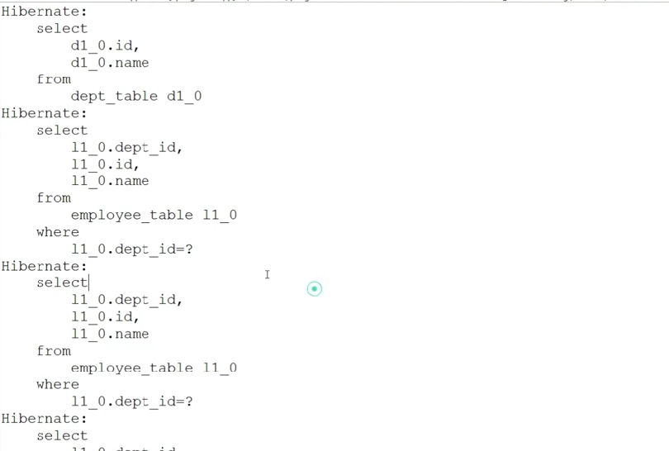
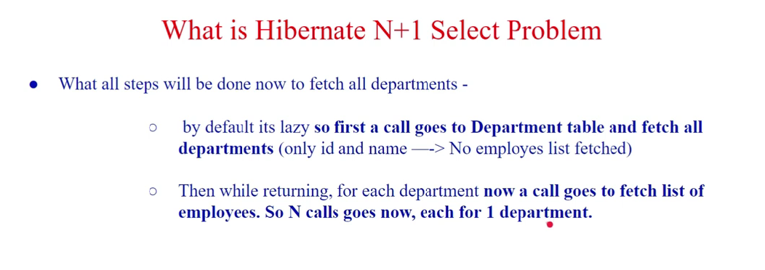
N+1 Problem Solution
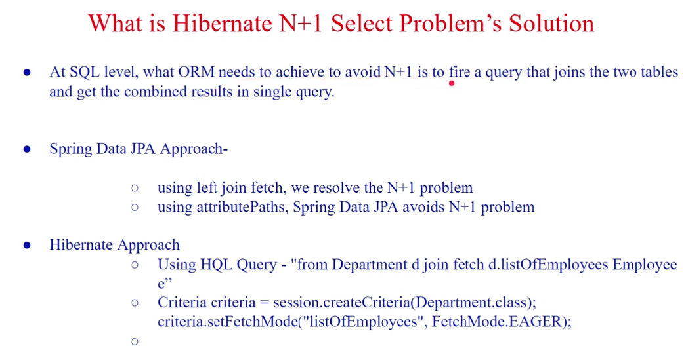
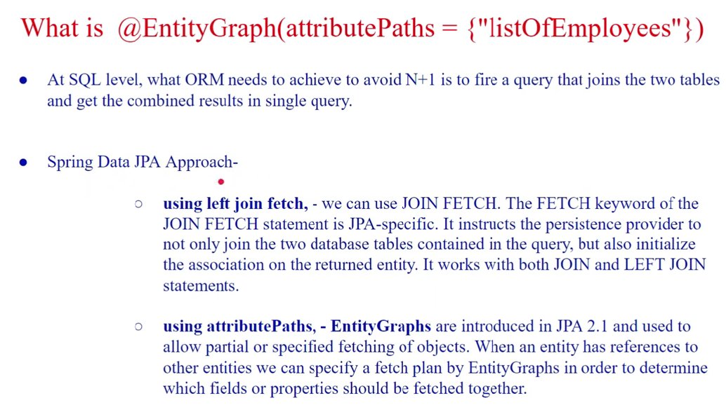
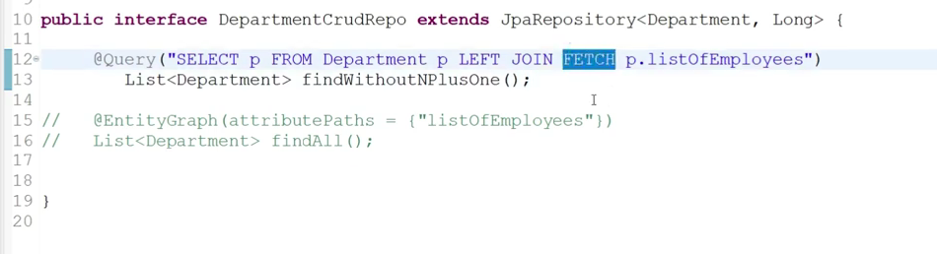
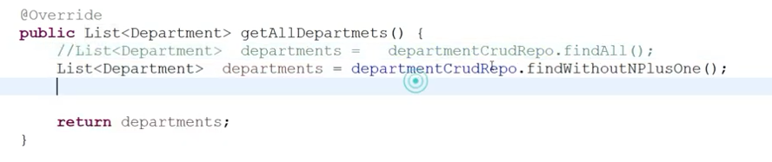
Now, only one query executes
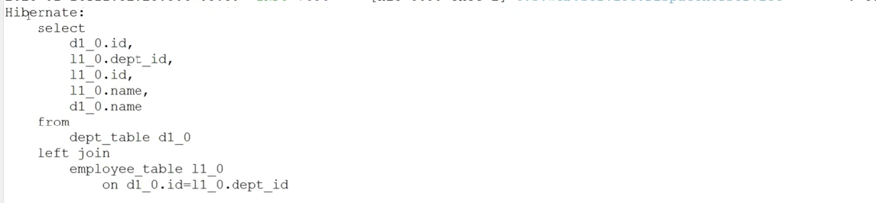

Spring Data JPA – Approach using Entity Graph
